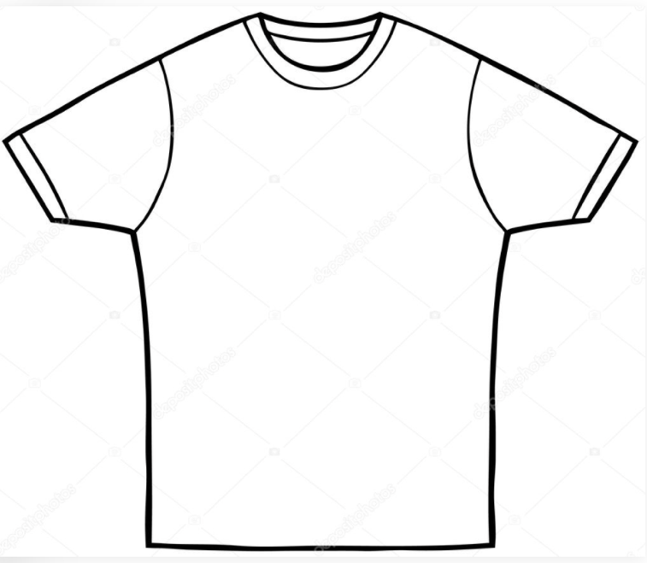

Forge Theatre
T-shirt Shirt
Order Form
(Blue shirt with black silkscreened logo)

Name: ________________________________________

Phone Number: ________________________________

Shirt Size: (T-shirts are $10, $1 extra for each size over XL)

SIZE Cost X Number = Total

SMALL $10 X ________ = $ ________

MEDIUM $10 X ________ = $ ________

LARGE: $10 X ________ = $ ________

X-LARGE: $10 X ________ = $ ________

2 X: $11 X ________ = $ ________

3 X: $12 X ________ = $ ________
Make checks payable to Forge Theater and mail to:

Forge Theatre
Attn: shirts
P.O. Box 474
Phoenixville, PA 19460

TOTAL # OF SHIRTS: ________

TOTAL COST OF ALL SHIRTS: ________

